* **EDUTAINERS**

**Series – I Specialist of Sciences Date: 28/02/18**

**BIO Ch # 7 T11 1st Year Time: 75min Marks: 40**

**Name: _________________________ Objective**

**Q1: Choose the Correct Answer** **(10 x 1 = 10)**

|  |  |  |  |  |  |  |  |  |
| --- | --- | --- | --- | --- | --- | --- | --- | --- |
| **1** | **The sexual process exhibited by most ciliates is called:** | | | | | | | |
| **a.** | | Oogamy | **b.** | Binary fission | **c.** | Conjugation | **d.** | Fertilization |
| **2** | **Amoebic dysentery is caused by:** | | | | | | | |
| **a.** | | Amoeba | **b.** | Ent-Amoeba | **c.** | Vorticella | **d.** | Plasmodium |
| **3** | **African sleeping sickness is caused by:** | | | | | | | |
| **a.** | | Ent-amoeba | **b.** | Trypanosome | **c.** | Vorticella | **d.** | Pelomyxa |
| **4** | **Chlorella is:** | | | | | | | |
| **a.** | | Multicellular | **b.** | Acellualar | **c.** | Unicellular motile | **d.** | Unicellular non motile |
| **5** | **Algae which take part in building coral reefs along with coral animals are:** | | | | | | | |
| **a.** | | Diatomes | **b.** | Red algae | **c.** | Green algae | **d.** | Brown algae |
| **6** | **Amoeba move and obtain food by means of:** | | | | | | | |
| **a.** | | Plasmodium | **b.** | Flagella | **c.** | Cillia | **d.** | Pseudopodia |
| **7** | **Pelomyxa palustris is:** | | | | | | | |
| **a.** | | Bacterium | **b.** | Amoeba | **c.** | Ciliate | **d.** | Zooflagellate |
| **8** | **In five kingdom system of Robert Whittaker (1969) only unicellular eukaryotes were placed in kingdom:** | | | | | | | |
| **a.** | | Monera | **b.** | Protista | **c.** | Fungi | **d.** | Plantae |
| **9** | **Algae which have shells composed of two halves that fit together like petri dish:** | | | | | | | |
| **a.** | | Brown algae | **b.** | Diatomes | **c.** | Green algae | **d.** | Red algae |
| **10** | **Which of the following causes sleeping sickness:** | | | | | | | |
| **a.** | | Trichonymphas | **b.** | Trypanosome | **c.** | Choanoflagellaes | **d.** | None |

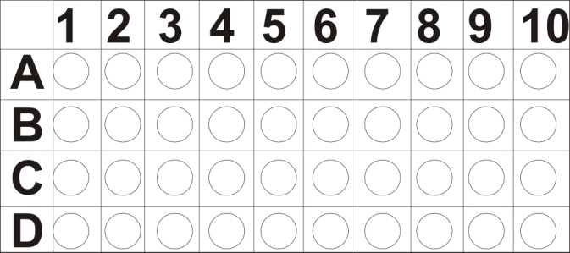

**SUBJECTIVE**

**Q2: Short Question** **(11 x 2 =22)**

1. How algae differ from plants?
2. What is a Giant Amoeba?
3. What are Foraminiferans and Actinopods?
4. Difference between diatoms and dinoflagellates.
5. What are limestone deposits? How are they formed?
6. Write two characteristics of ciliates.
7. Why phytophthora infestan was famous for?
8. Differentiate coral from coral reef.
9. Give two example of unicellular green algae.
10. Name four major groups of Kingdom Protista.
11. What are dinoflagellate?

**Q3: Long Question (8)**

1. Explain the fungus like protest.
2. Explain the life cycle of apicomplexans